Lesson 1.1: What was your favorite toy as a child?

Is gender associated with certain favorite childhood toys?

Collect class data using the chart below.

- Which of the following was your favorite toy as a child? Mark your choice on the board. Females white chalk. Males use yellow chalk.

Barbie | Legos | Action Figures | Video games | Bratz

- Identify the individuals and variable?

- Is the variable categorical or quantitative?

- Go to stapplet.com to enter the class data. Make a bar graph and a pie chart. Sketch them below.

- Sometimes it is helpful to graph more than one variable. Complete the table below.

Find each of the following:
 |  | Gender
 |  | Male | Female
 | Barbie
 | Legos
Type of toy | Action Figures
 | Video games
 | Bratz

% of students who chose Legos:

% of students who are Male and chose Action Figures:

% of Females who chose Legos:

- How many variables does the table have? Are the variables categorical or quantitative?

- Which variable would best explain or predict the other variable?

- Go to stapplet.com and enter the data. Make a side-by-side bar graph and a segmented bar graph. Sketch them below.

- How do the bars in the side-by-side-bar graph relate to the bars in the segmented bar graph?

- Is there an association between gender and type of toy? If so, describe it.

- If there was not an association between gender and toy, what would the graphs look like?

Important Ideas:

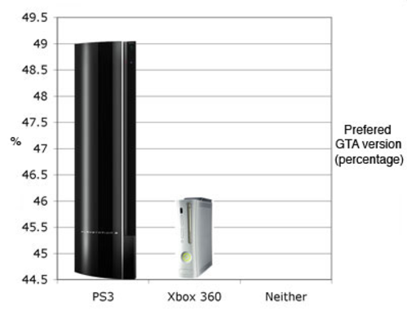
Check Your Understanding:
- Students at a local high school were asked which gaming system they preferred: the Playstation 3, the Xbox 360 or neither. The graph shown at right shows the results. Explain why the graph may be misleading.

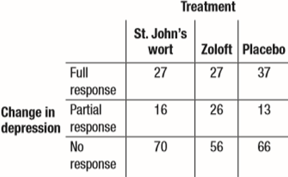
- An article in the Journal of the American Medical Association reports the results of a study designed to see if the herb St. John’s wort is effective in treating moderately severe cases of depression. The study involved 338 patients who were being treated for major depression. The subjects were randomly assigned to receive one of three treatments: St. John’s wort, Zoloft (a prescription drug), or placebo (an inactive treatment) for an 8-week period. The two way table summarizes the data from the experiment.

- What proportion of subjects in the study were randomly assigned to take St. John’s wort? Explain why this value makes sense.

- Find the distribution of change in depression for the subjects in this study using relative frequencies.

- What percent of subjects took Zoloft and showed a full response?

1.1 # 1-27 odd,28-32

