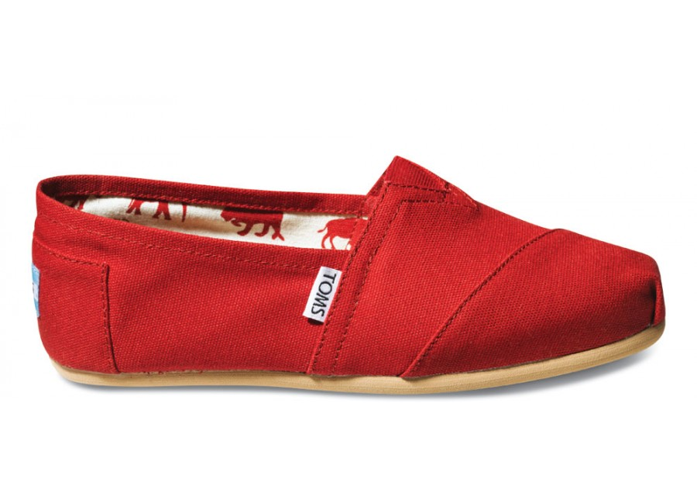
Lesson 1.2: How many pairs of shoes do you own?
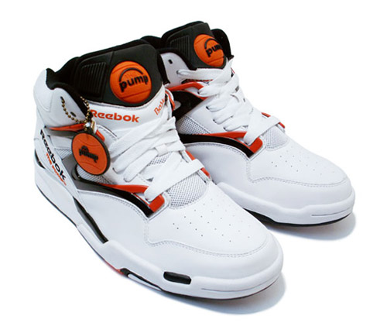
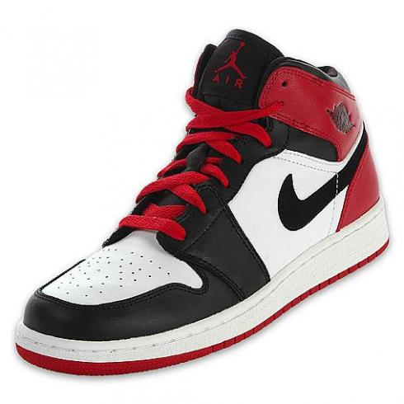

1. How many pairs of shoes do you own? Mark your choice on the board. Females use a red marker. Males use a green marker.

2. Is “Number of pairs of shoes” a categorical or quantitative variable?

3. Enter the data at www.stapplet.com. Make a dotplot, stemplot, and histogram and sketch below.

4. Describe the distribution of the number of pairs of shoes for your class.

Shape:

Outliers:

Center:

Spread:

5. Which of the three types of display do you prefer? Why?

6. How do the number of pairs of shoes for females and males compare? Start by separating the data.

Number of pairs of shoes – females Number of pairs of shoes - males

7. Enter this data at stapplet.com. Be sure to make 2 groups (female and male).

8. Make dotplots, a side-by-side stemplot, and then histograms. Copy one of these graphs below.

9. Compare the distributions of the number of pairs of shoes for females versus males. Be sure to address shape, outliers, center, and variability.

Lesson 1.2 – Displaying Quantitative Data
Check Your Understanding:
Important Ideas:
1. The dotplot displays the scores of 21 statistics students on a 20-point quiz.
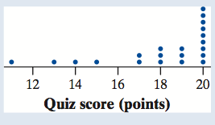
(a) What percent of students scored higher than 16 points?

(b) Describe the shape of the distribution.

(c) Are there any potential outliers? Why?

2. Here is a back-to-back stemplot of 19 middle school students’ resting pulse rates and their pulse rates after 5 minutes of running.
Write a few sentences comparing the distributions of
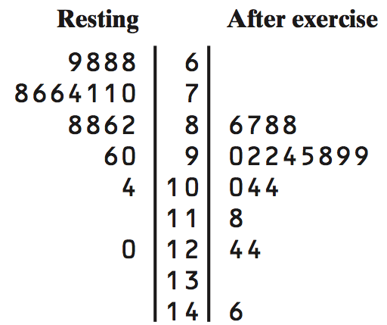
resting and after-exercise pulse rates.

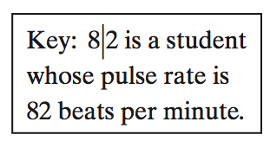

1.2 # 37-47 odd,53-59 odd,60,69-74

