**Lesson 1.3A: How many colleges are you applying to?**

icon175x175

icon175x175icon175x175

How many different colleges is your group of 4 applying to? Find the total number of colleges for your whole group.

1. Record the data for the class here.

2. Calculate the mean and median for the set of data. Compare them.

|  |  |  |
| --- | --- | --- |
| Value | Distance from mean | (Distance from mean)2 |
|  |  |  |
|  |  |  |
|  |  |  |
|  |  |  |
|  |  |  |
|  |  |  |
|  |  |  |
|  |  |  |
| Total: | |  |
| Average (Distance from mean)2: | |  |

3. What is the range of the data?

**Finding Standard Deviation**

4. Finding range is helpful but it does not tell us how spread out the data is between the minimum and maximum. How can we find the ***average distance of the values from the mean****?*

a. Complete the table.

b. The average you calculated is the average of the **squared distances** from the mean. How do we use this to find the **average distance from the mean**? Find it.

5. Go to stapplet.com. Enter the classroom data and find the summary statistics. Verify our work. How does it compare?

6. We forgot to add Mr G. He applied to 30 colleges (#overachiever). Add him to the data set. Calculate the new mean, median and standard deviation using the applet. How does it compare to the original measures? Why do you think this is?

Lesson 1.3 – Describing Quantitative Data with Numbers

Big Ideas:

Check Your Understanding:

Some students purchased pumpkins for a carving contest. Before the contest began, they weighed the pumpkins. The weights in pounds are shown here, along with a histogram of the data.

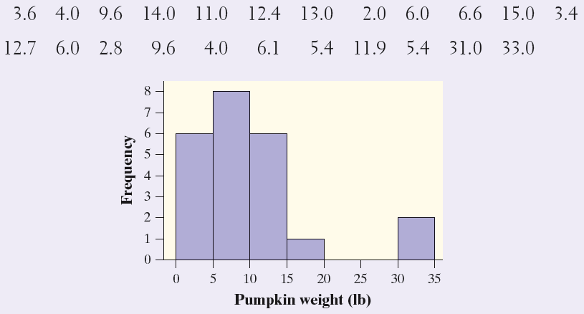

1. Calculate the mean weight of the pumpkins.
2. Find the median weight of the pumpkins.
3. Would you use the mean or the median to summarize the typical weight of a pumpkin in this contest? Explain.

**Begin 1.3 #79,81,83,87,89,91,93,95,97,103,105,107-110**