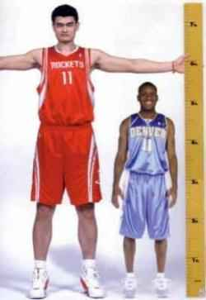**Lesson 1.3B: Where Do I Stand?**

icon175x175icon175x175

How does my height compare with other AP Stats students?

In pairs, measure each other’s height, rounded to the nearest inch.

Record your height on the dotplot at the front of the room (females use red, males use green).

Make a line at the front of the room, shortest to tallest.

1. Record the dotplot



2. What is the median height? Describe how you found it.

3. What is *Q*1 and *Q*3? Describe how you found them.

4. Record the following values and then use them to make a boxplot.

Minimum: *Q*1: Median: *Q*3: Maximum:



4. The **interquartile range** (or *IQR*) is defined as *Q*3 − *Q*1. Find the *IQR*. Where do you see the *IQR* in the boxplot?

5. An **outlier** is a data value that is way too small or way too big (using the rules below). Are there any outliers? Show your work.

Way too small < 

Way too big > 

6. Now we will separate our data into two groups, females and males.

Heights for females – find the following values and then make a boxplot.

Minimum: *Q*1: Median: *Q*3: Maximum:



Heights for males – find the following values and then make a boxplot.

Minimum: *Q*1: Median: *Q*3: Maximum:



Write a few sentences comparing the distribution of heights for girls with the distribution of heights for boys.

Lesson 1.3 – Describing Quantitative Data with Numbers

Big Ideas:

Check Your Understanding:

The following boxplots show the total income of 40 randomly chosen households each from Connecticut, Maine, and Massachusetts, based on U.S. Census data from the American Community Survey. Compare the distributions of annual incomes in the three states.

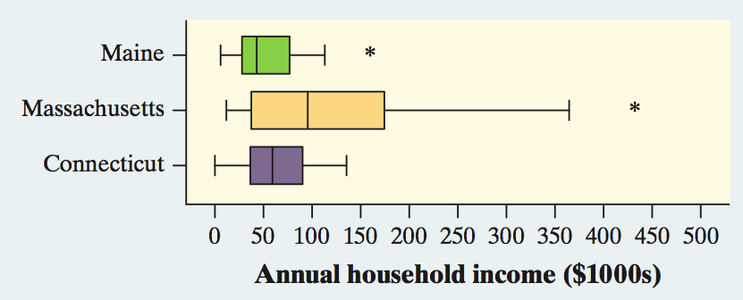

**Finish 1.3 #79,81,83,87,89,91,93,95,97,103,105,107-110**